CURRICULUM VITAE
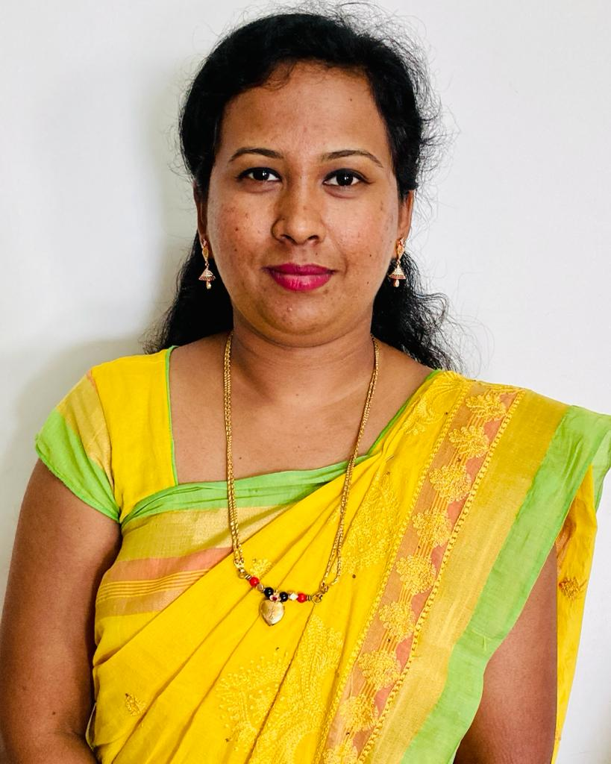
SUSHMA V
#10, “Bethel”, Vittal Block,
Old Kesare, Mysore – 570 003.

e- mail : sushmavaradaraju21@gmail.com

Contact No.: 8147504344

CAREER OBJECTIVE

To succeed in an environment of growth and excellence. To acquire a position and contribute as a team member in a lively work environment focused on promoting growth by providing better worth and service utilizing my communication, technical and organizational skills.

EXPERIENCE DETAILS

- Working as Assistant Professor in the Dept. of CSE, Seshadripuram Institute of Technology, Mysuru.
- Worked as Assistant Professor in the Dept. of CSE, ATME College of Engineering, Mysuru, 2021 – 25.

- Worked as Assistant Professor in the Dept. of ISE, GSSSIETW, Mysuru, 2016 – 18.

RESEARCH DETAILS

- Pursuing PhD at Visvesvaraya Technological University.
- Area of Interest : Machine Learning, Deep Learning, Image Processing
- Status of Research : Comprehensive Viva Voce Completed
- Progress : Woking towards the research objectives and Open Seminar – 1

CERTIFICATIONS

- Completed certification in Module -1 Orientation towards Technical Education and Curriculum Aspects of National Initiative for Technical Teachers Training, February 2024.
- Attended Institute Innovation Ambassador Training – Foundation Level conducted by MoE’s Innovation Cell & AICTE, September 2022.
- Attended Institute Innovation Ambassador Training – Advanced Level conducted by MoE’s Innovation Cell & AICTE, September 2022.
- Completed Java course certified by the Oracle Workforce Development Program.

- Completed Java and Web Component Development with Servlets and JSPs during the year 2013, certified by Aptech, Bangalore.

- Completed Honours Diploma in Software Technology during the year 2008, certified by Cyber Metric Software (CMS), Bangalore.

FACULTY DEVELOPMENT PROGRAMS

- Attended 3 Days FDP on “Artificial Intelligence, Machine Learning and Deep Learning in the Data Revolution Era : Progress and Applications” organized by Dept. of CSE an AI & ML at ATME College of Engineering, Mysuru from 3rd February to 5th February 2025.
..2..

2

- Attended 3 Days FDP on the theme “Inculcating Universal Human Values in Technical Education” organized by All India Council for Technical Education (AICTE) at ATME College of Engineering, Mysuru from 2nd November to 4th November 2023.

- Completed / attended 6 days AICTE Training and Learning (ATAL) Academy Faculty Development Program on “Cyber Security for Industry 4.0” at RV College of Engineering, Bangalore from 09/10/2023 to 14/10/2023.

- Attended 3 days online FDP on “Object Oriented Programming with Java Laboratory” organized by Department of Computer Science and Engineering & Department of Information Science and Engineering, Sri Krishna Institute of Technology in association with Technical Institute for Engineers (TIE), Bangalore from 27th October 2022 to 29th October 2022.

- Attended 5 days FDP on “Art of Research Paper Writing And IPR Level 2” organized by Department of Information Science and Engineering, Sri Krishna Institute of Technology in association with Technical Institute for Engineers (TIE), Bangalore from 20th September 2022 to 24th September 2022.

- Attended 3 day National Level Seminar on “Research Avenues in Artificial Intelligence and Allied Areas” sponsored by Science and Engineering Research Board (SERB), New Delhi from 24th to 26th March 2022.

- Organized a workshop on “Awareness on Virtual Lab & its Utilization”, at Dept. of CSE, ATMECE, Mysuru in association with NIT-K, Surathkal on 5th March 2022.

- Conducted a seminar on “Entrepreneurship Opportunities – A career Guidance to the young minds” as a Resource Person under Institutions Innovation Council (IIC), ATMECE, Mysuru on 22nd February 2022.

- Attended FDP / 5 day training program on “An overview of Teaching Techniques in Innovation and Design Thinking” organized by AICTE – VTU from 06/12/2021 to 10/12/2021.

- Attended Technical talk on Artificial Intelligence and Machine Learning”, organized by the department of Electronics and communication, GSSSIETW, Mysuru on 14th November 2017.

- Attended Three Days Faculty Development Program on Recent Trends in Nanoscience & Technology”, organized by Basic science department, GSSSIETW, Mysuru on 13th October 2017

- Attended one day FDP on “Collaborative Research & Pedagogy”, organized by Electrical & Electronics department, GSSSIETW, Mysuru on 3rd August 2017

- Attended Five Days National Level Faculty Development Program on “Cyber Warfare: Techniques, Tactics & Tools for Network Security” at GSSSIETW, Mysuru from 24th July to 28th July 2017.

..3..

3

- Attended webinar on “Rainfall scenario in Karnataka” conducted by Karnataka State Council for Science and Technology (KSCST) by Dr. G S Srinivasa Reddy, Director, Karnataka State Natural Disaster Monitoring Center, Bengaluru on 16th June 2017 at GSSSIETW, Mysuru.

- Attended One day FDP on “Research Methodology & Teaching Information Security: An Overview” on 9th June 2017 organized by ISTE at GSSSIETW, Mysuru.

- Attended State Level Workshop on “Research, Innovation & Challenges” on 13th May 2017 at MIT, Mysuru.

- Attended One day FDP on “Recent Trends in Science & Mathematics (RTSM-2017)” on 11th Jan 2017 at GSSSIETW, Mysuru.

- Attended Technical Talk on “Engineering Research Opportunities” on 8th December 2016 Dr. Krishnaraj Madhavjee Sunjiv Soyjaudh, Professor of Communication Engineering, Faculty of Engineering, University of Mauritius, Republic of Mauritius, at GSSSIETW, Mysuru.

- Attended One day workshop on “Women in Power Engineering” on 16th December 2016 at GSSSIETW, Mysuru

- Attended One day Hands-on/Workshop on Cloud Computing by Mr. Dastikop and Mr. Mayur Patil on 20th July, 2016 in GSSSIETW, Mysuru.

- Attended One Day FDP on R & D Funding Opportunities and Introduction to IPR By Mr. Cyril Prasanna Raj, MS College of Engineering on 21st July, 2016 in GSSSIETW, Mysuru.

PRESENTATIONS & PUBLICATIONS

- “Implementation of Wildlife Conservation Using AI” in International Journal of Creative Research Thoughts, Volume 13, Issue 2, February 2025.
- “Machine Learning Based Traffic Rules Violation System” in International Journal of Creative Research Thoughts, Volume 13, Issue 2, February 2025.
- “Automated Architecture Design For Solar Irradiance Prediction” in International Journal of Creative Research Thoughts, Volume 12, Issue 5, May 2024.
- “Heart Attack Risk Prediction Using Retinal Eye Images Based on Machine Learning and Image Processing” in the International Conference on Recent Trends in Science & Technology ICRTST – 2023 organized by ATME College of Engineering, Mysuru, on 18th & 19th October 2023.
- “Fitness Trainer Application using Artificial Intelligence” in International Research Journal of Engineering and Technology (IRJET), Volume 10, Issue 5, May 2023.
- “Division and Replication of Data in Cloud” in the International Conference on Recent Trends in Science & Technology ICRTST – 2022 held at ATME College of Engineering, Mysuru in association with AICTE on 14th & 15th July 2022.
..4..

4

- SCOPUS INDEXED - “Plant Health Monitoring System using IOT” in the International Conference on Recent Trends in Science & Technology ICRTST – 2022 held at ATME College of Engineering, Mysuru in association with AICTE on 14th & 15th July 2022.
- “Collaboration of Blockchain in Healthcare 4.0” in International Journal of Advanced Research in Computer and Communication Engineering, Volume 11, Issue 6, June 2022.
- “LID Systems For Speech Processing Systems” in International Journal of Creative Research Thoughts, Volume 10, Issue 6, June 2022.
- “Integration of Database Management System with Cloud” in International Journal of Computer Applications Technology and Research, Volume 6, Issue 12, December 2017.

- Won Best Paper award for the paper presentation titled “Software Architecture Reconstruction Method : A Survey” in Best practice Symposium – 2017 organized by GSSSIETW, Mysuru on 31st July 2017.
- “Efficient Underwater Communication Using Mobile Sink”, in International Advanced Research Journal in Science, Engineering and Technology (IARJSET), Volume 4, Issue 4, April 2017.
- “Oracle Strategy for Enhanced Security in Data Warehouse” presented at Best Practice Symposium – 2017 on 21st January 2017 held at GSSSIETW, Mysuru.
- “A Survey on Edge-Based Color Constancy for Image”, in International Journal of Innovative Research in Electrical, Electronics, Instrumentation and Control Engineering, Volume 4, Issue 11, November 2016.
- “Clustered Fair Data Transmission in Energy Efficient UWSNs”, in International Journal of Advanced Research in Computer and Communication Engineering, Volume 5, Issue 10, October 2016.
- “Time Synchronized Fair Data Transmission in Secure UWSNs”, in International Journal of Science and Research, Volume 4, Issue 6, June 2015.
- “Wireless Detector with GPS for Heart Attack” presented at National Conference on Emerging Trends in Technology, on 2012 held at Nagarjuna College of Engineering & Technology, Bengaluru.

ROLES and RESPONSIBILITIES

- NAAC and NBA Criteria Coordinator (2021-25)
- EMS Coordinator (2021-22, 2022-23)
- Institute Innovation Council Coordinator (2021-22, 2022-23)
- Virtual Lab Coordinator (2021-25)
- Technical Event Coordinator (2021-22, 2022-23)
- Student Mentor (2021-25)
..5..

5

PROFESSIONAL MEMBERSHIP

LM ISTE – 113683

ACHIEVEMENTS

- Received an award as “Student of the Year” during final year of BE, Brindavan College of Engineering, Bangalore.

- Received certificates for being topper in academic semesters during BE.

- Awarded “Academic Excellence Semester Topper” during M.Tech 2013 – 15, CMRIT, Bangalore.

ACADEMIC CREDENTIALS

EXAMINATION PASSED | SPECIALIZATION | UNIVERSITY | INSTITUTE | YEAR OF PASSING | % OF MARKS
M.Tech | Computer Science and Engineering | Visvesvaraya Technological University | CMR Institute of Technology, Bangalore | 2015 | 82.42
BE | Information Science and Engineering | Visvesvaraya Technological University | Brindavan College of Engineering | 2013 | 74.93
P.U.C | PCMC | Department of Pre – University Education | Maharani Lakshmi Ammanni Women PU College, Bangalore | 2009 | 66.00
S.S.L.C | ---- | Karnataka Secondary Education Examination Board | M.S. Ramaiah Vidyaniketan, Bangalore | 2006 | 89.12

PERSONAL DETAILS
NAME | : | SUSHMA. V
HUSBAND NAME | : | AJAY KUMAR. V
DATE OF BIRTH | : | 21/08/1990
SEX | : | Female
NATIONALITY | : | Indian
RELIGION | : | Christian
MARITAL STATUS | : | Married
LANGUAGES KNOWN | : | Kannada, English, and Hindi.
DECLARATION

I declare that the above stated information are true and correct to the best of my knowledge.

Date :

Place : Mysuru ( SUSHMA V )

